**CONCEPTS AND PRINCIPLES OF GSM NETWORKS**

**CMP 406**

**BY**

**AJIBOYE OLUWAFERANMI KELECHI**

**180202003**

**JUNE 2022**

**ABSTRACT**

This paper covers the scope, concepts and principles of Global System for Mobile communication (GSM) networks. For this purpose, the history, applications, growth and major components of GSM systems are reviewed. In this paper, the benefits of GSM networks and how they can be advanced to contribute to the society are discussed

**CHAPTER ONE**

**INTRODUCTION**

Global System for Mobile Communiaction (GSM) is a worldwide acceptable set of protocols for digital cellular communication. GSM is the labelled term established in 1982 to develop a unified European mobile telecommunications standard that would give rise to specifications for an European mobile cellular radio system with a frequency of 900Mhz (IEC, 1997). It is approximated that several nations beyond Europe will eventually join the GSM partnership. GSM networks possess the potential to transmit 64kbps to 120mbps of data rates. In 2000, there were more than 1 billion GSM subscribers in more than 200 nations around the world (Angela, 2001)

**CHAPTER TWO**

**SCOPE AND COMPONENTS OF GSM**

The GSM is the most famous mobile telecommunication system in the world, with a total of more than 3 billion subscibers as of 2010 (Brady, 2022). GSM allows users to operate their devices from anywhere in the world with a GSM connection. GSM phones operate on a Subsciber Identity Module (SIM card). A SIM card is a small card-like device that communicates with the GSM network which phone is which and allows the user to store information like contact names, messages etc (Deitz, 2019).

**GSM in Wireless Communication**

GSM makes use of 4 different bands of frequency: 850MHz, 900MHz, 1800 MHz and 1900 MHz. It uses the Concept of Frequency Division Multiple Access (FDMA) and Time Division Multiple Access (TDMA)

FDMA is the simplest method of generating channels by assigning users to non-conflicting frequency bands. FDMA technique was first implemented in 2G systems (Wymeersch & Eryilmaz, 2016)

TDMA is a digital communication technology that gives way to a cetain amount of users to enter a single radio-frequency channel without intrusion by alloting individual time slots to users in each channel (Garg & Wang, 2005).

Features of GSM in Wireless Communication include:

1. Supports international roaming
2. Enables clear voice clarity for users
3. It has the ability to support several mobile devices
4. International Integrated Service Digital Network (ISDN) compatibility.

GSM is a larger system that comprises of three subsystems:

1. BSS: Base Station Subsystem handles traffic and communication signals from a mobile phone and the network subsystem.
2. NSS: Network and Switching Subsystem is the core network of GSM. NSS is responsible for all call and mobility management tasks for mobile devices currently in the network
3. OSS: Operating Subsystem is a practical system which the network operator monitors and uses as an administrative tool to manipulate the system (Prachi, 2022)

**Architecture of GSM**

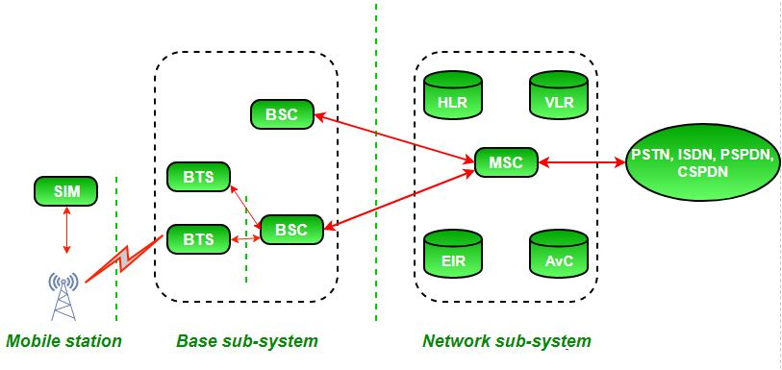

Figure 1: Architecture of a GSM network

As shown in figure 1, a GSM network consists of a Mobile station, a Base sub-system and a Network sub-system. Each consists of various entities that will be discussed below:

1. Mobile station (MS) : This simply means a mobile phone
2. Base transceiver system (BTS) : Is responsible for the care of the radio component with MS.
3. Base station controller (BSC) : It is used is to share important time slots between the BTS and MSC.
4. Home location register (HLR) : It is the reference storage location for subscriber variables like subscriber’s ID, location, authentication key, etc.
5. Visitor location register (VLR) : It consists of a duplicate of most of the information contained in HLR which is temporary and is available only until the subscriber is active.
6. Equipment identity register (EIR) : It is a database that consists a list of accurate mobile infrastructure on the network.
7. Authentication center (AuC) : It performs authentication of users.

**Applications of GSM**

A notable point from above discussions is that GSM plays a vital role in every technological individual or enterprise all around the world. Below are some of the many applications of GSM technology available today:

1. Transaction Terminals: GSM plays a vital role in POS and other checkout counters nowadays. Users can choose to pay for goods and services without cash. The use of a debit/credit card to as a payment method has gained popularity since the 1990s (Pearce, 2019)
2. Security applications: GSM is the most secured cellular telecommunications network available today. It has it’s methods of security standardized, and due to this fact GSM is applicable in securing mobile devices to prevent unauthorized access and data leaks in mobile applications. (Tutorialspoint, 2022)
3. Digital Weather Stations: GSM has found application in implementing digital weather stations for weather forecast and weather reports. It also stores weather data for scientists and data analyzers. A GSM weather station consists of 3 sensors: Temperature, Light and Humidity. These values are displayed on an Liquid Crystal Display (LCD) as well as the weather reports (Tronix, 2009)
4. Medical Services: Using GSM communication technologies, any situation can be handled just by transmitting the patient details through the communication network and receiving them and processing them at the receiver section-either at the healthcare center or at the doctor’s home. The doctor simply monitors the patient details and gives back the instructions to the person so that he can at least take some precautions before finally reaching the hospital.

These are just a few of the many possible applications of GSM networks. Transportation, Gaming, Motion and Audio capture as well as many more can be performed using GSM systems

**CHAPTER THREE**

**FUTURE OF GSM NETWORKS**

Mobile telecommunication networks and service providers have shown amazing business strength throughout last year in spite of the increased demand put on them. And besides the operational difficulties of assemblng demand now, operators have continued to pursue new 5G launches and expand 5G roll outs apace. Simultaenously, the world has been engaging in more audio and video calls and looking for new ways to communicate, or to collaborate, while spending more time remote from their friends and colleagues. (Fogg, 2020)

Below are some predictions for GSM networks as the future approaches

1. 2G and 3G will become deactivated

Because of the high demand for 5G, operators will collaborate with regulators to phase out 3G services on existing frequency bands, allowing more capacity to be allocated to more efficient 5G technology. In Germany, we've seen evidence of 3G changes. While in the United States, AT&T has been juggling 4G airwaves to improve its 5G offering. However, carriers must be cautious not to exacerbate the digital divide in regions where mobile consumers lack current 4G or better gear and continue to use older 2G or 3G handsets (Opensignal, 2021).

1. Spectrum

Finding more radio frequency to allocate to the 5G network is crucial. There are now 46 candidates for consideration and this is likely to increase even more. Furthermore, here is interest in the use of higher frequency bands, including the millimetre wave bands above 30GHz and this is likely to be discussed at a future World Radio event (Kumar & Kaliyaperumal, 2021).